For Social Media Recruitment

Where do you get your information about the Environment and Climate Change in the Appalachian Region?

You are invited to participate in the Climate Knowledge and Stories Survey a study concerning the understanding of climate, adverse weather events and environmental concerns in the Southern Appalachian Region. This study will seek to gather information about your climate change, and how you relate to that information.

Findings from our study will be included in research papers which Dr. Mimi Perreault, Dr. Wesley Wehde and select undergraduate and graduate students. Participants are asked to complete the study, which will take approximately 20 minutes.

You will be asked questions that will support research objectives around climate knowledge and information.

The risks associated with your participation are minimal, though loss of confidentiality will be a known aspect of participation. You do not need to share your personal information unless you are interested in participating in the study for multiple years or would be willing to participate in a follow-up interview.

If you submit a completed survey in its entirety, and are willing to provide your e-mail address, you will be entered into a drawing to win one of ten $25 dollar gift card codes to Amazon. The drawing will be held in February 2021. The estimated odds of winning are approximately 1 in 20. Exact odds depend on the number of entries into the drawing.

If you have any research-related questions or problems, you may contact me, Mimi Perreault perreault@etsu.edu or Wesley Wehde at Wehde@etsu.edu.

You will be asked questions that will support research objectives around climate knowledge and information:
IMAGES: 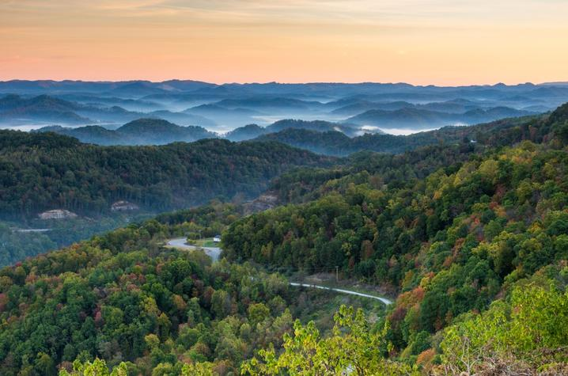
Credit Getty Images

Links to Qualtrics Link Provided:
https://etsusociology.co1.qualtrics.com/jfe/form/SV_3rqmy3ud8WSOtXD

