Instructions how to filter your results and print Turnitin report to PDF
1. To open Turnitin, click on the colored box to the right of the file name, this will open Turnitin software. If this box isn’t there double check to be sure originality checking has been enabled on this dropbox or wait until the report is finished.
2. Once you have your document open in Turnitin, click on the icon that looks like a funnel (circled in yellow below).
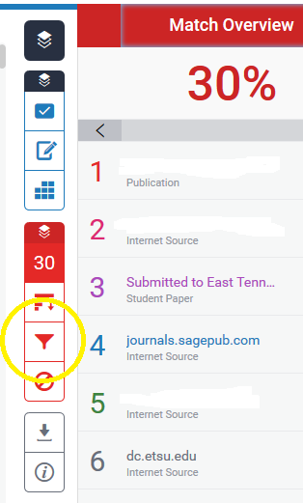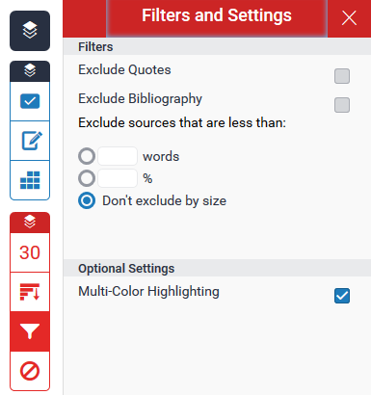
Then this window will open

3. Click on the check boxes next to "exclude quotes," then "exclude bibliography," and finally "exclude matches that are less than X words." You can fill in the number 6, 7, or 8 for good measure.

4. Click on Apply Changes at the bottom right of the page

5. Read through what Turnitin has flagged to determine if the material cannot be reworded (ex: titles, proper nouns, common phrases etc.), if the material was all or in part from a paper you wrote that was submitted to another D2L site, or if the material needs reworking. This evaluation process is meant to help you and your committee Chair determine if rewording, further citation, or better paraphrasing is needed, or if the manuscript has been properly cited throughout.
You can also exclude sources if you determine the thesis has large portions that are the student’s own work previously submitted to a D2L dropbox with Turnitin enabled. To do this, click on the percent to view the match breakdown for that percentage.
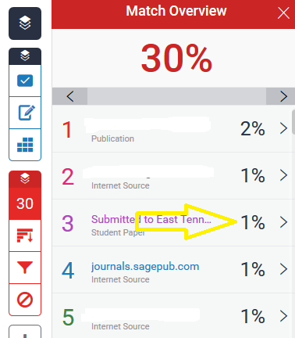
Then this will appear at the bottom right of the page; click to exclude that source from the report
6. By signing the Manuscript Review form, your committee Chair will confirm that he/she has reviewed the Turnitin report and it meets the best practice for citation. The entire report must be e-mailed to Emily Redd (redd@etsu.edu) for filing before the review process can begin.
7. To download a report in PDF format, click on the download icon (circled in yellow below).
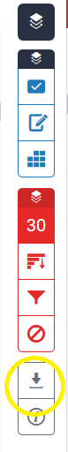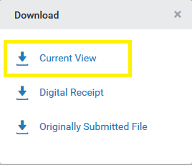
This window will open.
Download PDF of Current View for printing. This may take a few minutes.

8. Open the PDF or save to your computer.

