Document Search – New Experience Version

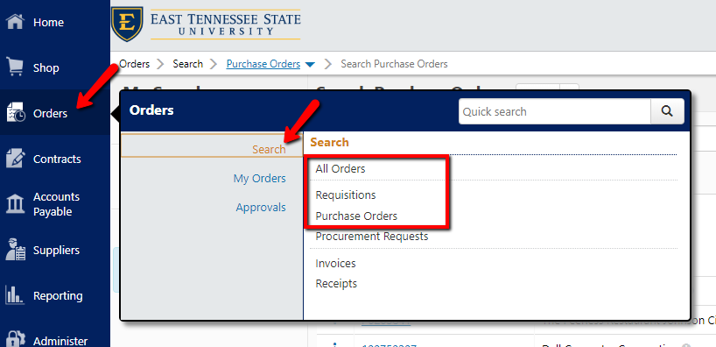
- Hover over Orders on the left vertical menu and a fly-out menu will appear.
- Hover over Search and you can select All Orders, or to refine your search select Requisitions or Purchase Orders to search that specific criteria.

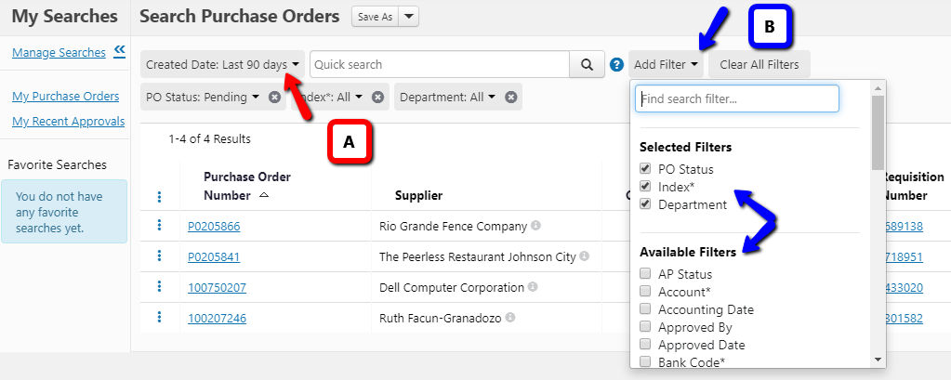
A) Add a date filter
- To add a date filter, click the Created Date drop-down arrow and adjust the date search criteria
B) Add other filters
- To add filters, click the Add Filter down arrow
- The filters you have selected will appear at the top of the drop-down
- Click the checkbox of any additional available filter you wish to search by

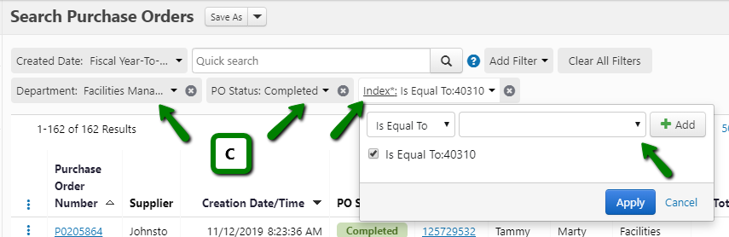
C) Filtering your search
- When you select a filter, it will show below the Quick Search bar
- Click each filter to input your search criteria in the drop-down field that appears

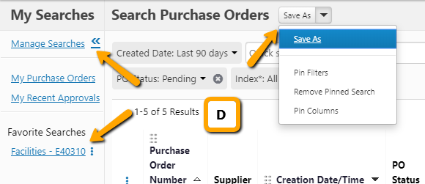
D) Pinning Filters & Saving Searches
- You can pin your filters by clicking Pin Filters under the drop-down arrow next to Save As. Those filters will be permanent until you remove them
- You can also save searches for quick access by clicking Save As (See E for additional instructions on saving searches)
- Your saved searches will appear under Favorite Searches on the left
- You can edit or delete saved searches by clicking Manage Searches

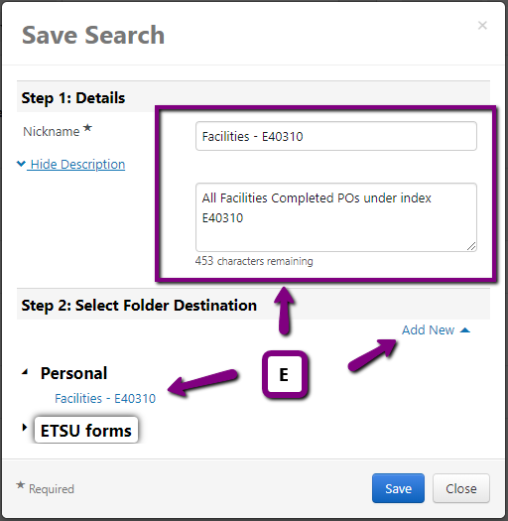
E) Saving Searches
- After clicking Save As, a box will appear.
- Give your search a Nickname and Description (description is optional)
- Click Add New to create a folder for your saved search or add to an existing folder under Personal
- Click Save when complete

