SECONDARY EDUCATION MINOR:

____ EDFN 2400 Foundations for Teaching (3)
____ EDFN 3301 Issues in Education (3)
____ EDFN 3310 Educational Psychology (3)
____ SPED 2300 Exceptional Learners in Schools and Communities (3)
____ MEDA 3570 Educational Technology (2)
____ READ 4657 Disciplinary Literacy: Assessing and Instructing Adolescents (3)
____ CUAI 4571 Pre-Residency: Classroom & Instruc Mgmt. in Middle and Secondary Schools (1) Summer
____ CUAI 4416 Residency I: Middle and Secondary School Curriculum, Methods, and Assessment (2) Fall
____ CUAI 4426 Residency I: Middle and Secondary School Curriculum and Methods Field Experience (1) Fall
____ THEA 4417 Residency I: Teaching Theatre in Grades K-12 (3) Fall

PROFESSIONAL SEMESTER: 12
_____CUAI 4580 Residency II: Student Teaching (9) Spring
_____CUAI 4581 Residency II: Seminar (3)   Spring

TOTAL HOURS FOR THE MINOR: 36

TEACHING CONTENT AREA LICENSE REQUIREMENTS (subject to change):
STUDENTS MUST ACHIEVE GRADES OF “C” OR HIGHER IN ALL MAJOR CONTENT CLASSES.
PRAXIS TEST AREAS SHOULD INFORM CHOICES IN ELECTIVES/CHOICES IN MAJOR COURSEWORK.
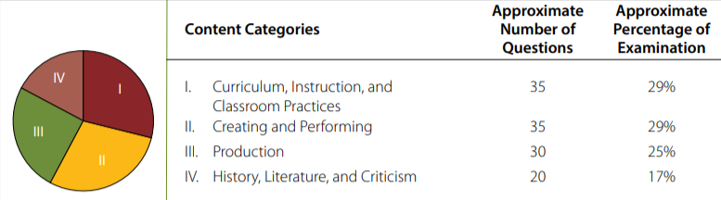
Figure 1. Content Categories for Praxis exam test code 5641 “Theatre”
________________________________________________________________________________________________________________________________________________________________________________________________

Additional major and degree requirements may apply. For major and degree requirements it is necessary to meet with your major advisor.

revised 3/9/2020

