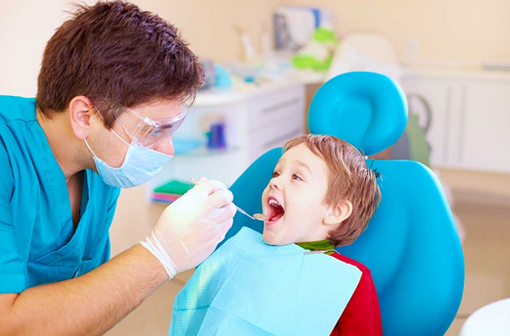
Mendota Spring Dentistry [Digital image]. (2016). Retrieved from https://www.mendotaspringsdentistry.com/age-first-take-little-one-dentist/

My Trip to the Dentist

How to Use This Story
When should I begin reading this story with my child?
Deciding when to begin reading this story depends on the needs and preferences of your child. Here are a few suggestions:
- When you first tell your child about the dentist’s office
- When you make your child’s first dentist appointment
- When you explain different types of doctors to your child

How often should I read this story with my child?
- As often as the child asks questions or seems to worry about the dentist
- The morning of the dentist appointment
- On the way to the dentist appointment
- While you and your child are in the waiting room at the dentist appointment
- Whenever your child shows interest in reading this book

You know your child best. Deciding when to begin and how often to read these stories is up to you and your child.

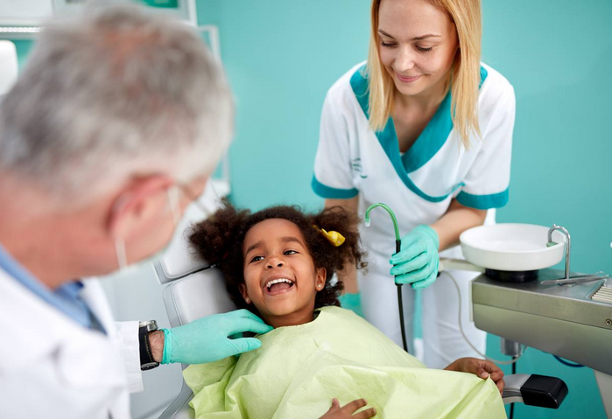

Summit Dental Health [Digital image]. (2017). Retrieved from https://summitdentalhealth.net/why-kids-dental-checkups-are-important/

I am going to the dentist. It is important for me to go to the dentist.

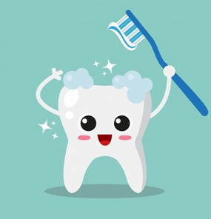
Clean teeth [Digital image]. (2017). Retrieved from https://www.freepik.com/free-vector/clean-tooth-background_1130798.htm

The dentist helps keep my teeth healthy and clean!

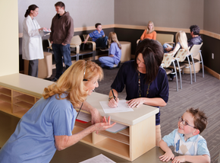

Stericycle [Digital image]. (2016). Retrieved from https://www.stericyclecommunications.com/blog/improve-customer-service-virtual-receptionist/medical-office-reception-area/

My family and I will walk into the dentist’s office and tell the person at the front desk that I am ready for the dentist.

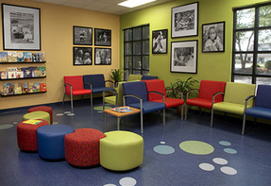
The Greensboro Center for Pediatric Dentistry [Digital image]. (n.d.). Retrieved from http://www.greatkidssmiles.com/office-tour.php

I will sit quietly in the waiting room with my family until someone calls my name.

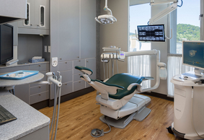
Northgate Dental Exam Room [Digital image]. (n.d.). Retrieved from https://www.northgatedental.com/portfolio/northgate-dental-exam-room/

I will walk to the room where my teeth will be cleaned and checked.

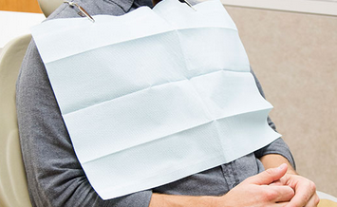

Graham Medical [Digital image]. (n.d.). Retrieved from https://www.grahammedical.com/product/bibs/

The hygienist will ask me to sit in a special chair. She will put a bib on me to keep my clothes clean.

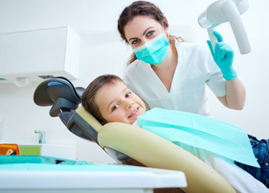
Child in chair [Digital image]. (2018). Retrieved from https://www.drviviani.com/blog/dentistry-for-children-can-help-to-prevent-the-need-for-future-orthodontics/

This special chair will help the hygienist see my teeth.

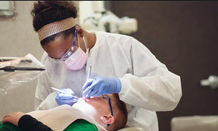
Shawnee State University [Digital image]. (n.d.). Retrieved from http://www.shawnee.edu/academics/health-sciences/dental-hygiene/index.aspx

The hygienist will put on gloves, a mask, and glasses to help her clean my teeth.

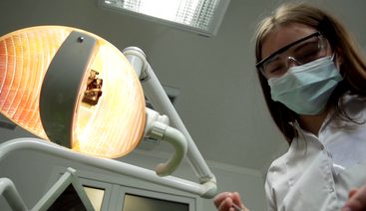

Storybocks [Digital image]. (n.d.) Retrieved from https://www.videoblocks.com/video/young-female-dentist-in-mask-approaches-with-tools-holding-a-mouth-mirror-and-dentists-hook-dental-lamp-lights-into-a-patients-mouth-standing-upon-a-patient-looking-at-camera-dentists-face-bob_eqgigj06h7nf4

The hygienist will turn on a light above my head. If the light is too bright, I can close my eyes or wear sunglasses.

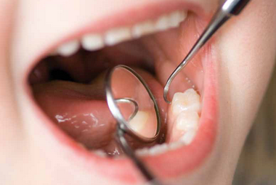
Ottawa Family Living [Digital image]. (n.d.). Retrieved from http://www.ottawafamilyliving.com/open_wide/

The hygienist will ask me to open my mouth wide so she can see my teeth.

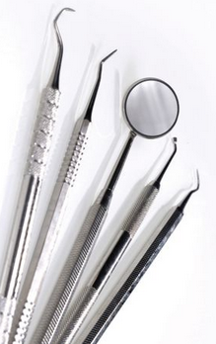

Dental instruments [Digital image]. (2015). Retrieved from https://www.nature.com/articles/bdjteam201527

The hygienist will use special tools to clean my teeth. Some of these tools might make my mouth shake, but that is okay!

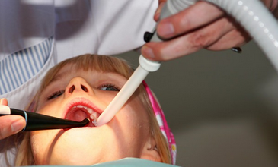

Racorn [Digital image]. (n.d.). Retrieved from https://www.oralanswers.com/dental-suction/

The hygienist may squirt water into my mouth and suck it out with a special straw, but that is okay!

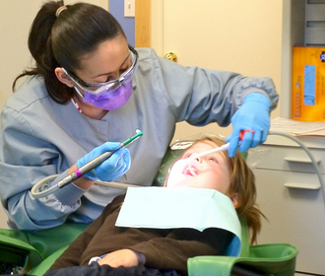

Toothbrush [Digital image]. (n.d.). Retrieved from http://dentalmerchandiser.com/

The hygienist will use toothpaste, a toothbrush, and floss to get my teeth ready for the dentist. The toothbrush may tickle and be noisy, but that is okay!

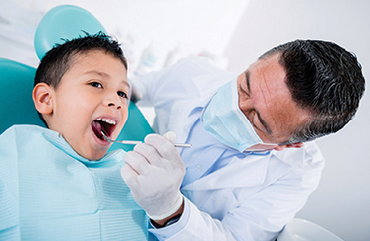
Westchester [Digital image]. (n.d.). Retrieved from http://www.westchestermagazine.com/Phelps-Today-Spring-2014-Newsletter-Homepage/Dental-Care-for-Children-Who-Need-Special-Treatment/

The dentist will come and check my teeth. The dentist will use special tools to count my teeth and make sure they are healthy.

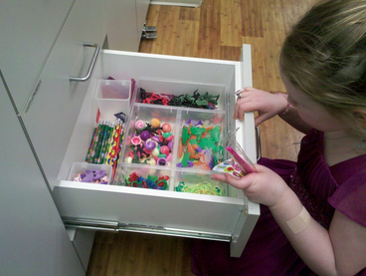

Prize Drawer [Digital image]. (2011). Retrieved from https://activerain.com/blogsview/2141640/remember-when-i-was-afraid-of-the-dentist-

When I am all done, I will get a prize and get a new toothbrush from the dentist’s office!

Imgflip [Digial image]. (n.d.) Retrieved from https://imgflip.com/memetemplate/113970601/Happy-kid

I did a great job at the dentist today! My teeth are healthy and clean. Now, it is time to leave!

This project is supported by the Health Resources and Services Administration (HRSA) of the U.S. Department of Health and Human Services (HHS) under grant #T73MC30767, Vanderbilt Consortium LEND. This information or content and conclusions are those of the author and should not be construed as the official position or policy of, nor should any endorsements be inferred by HRSA, HHS or the U.S. Government.

