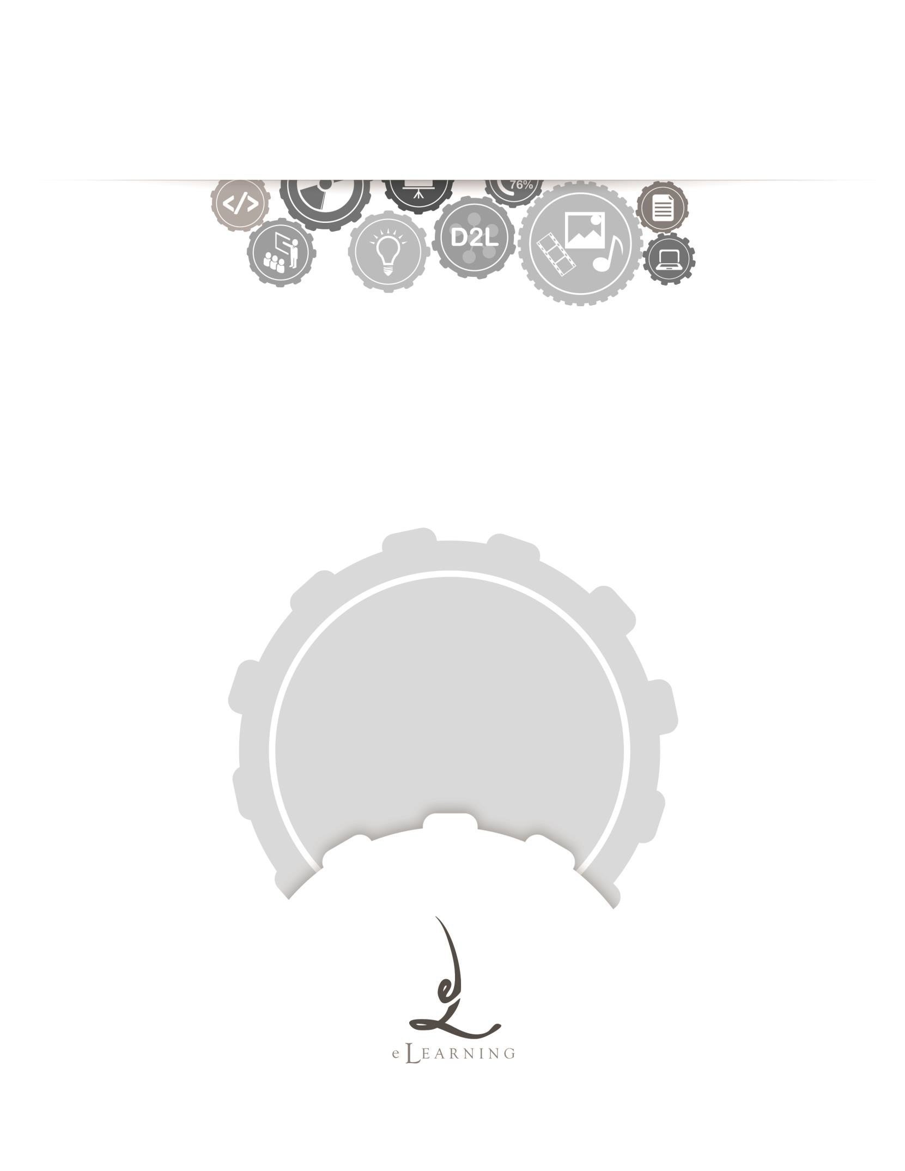
ACADEMIC TECHNOLOGY SUPPORT

Classlist
Student Quick Start Guide

ats@etsu.edu | 439-8611 www.etsu.edu/ats

Table of Contents:
Accessing Classlist 1
Navigating the Classlist 1
Email and the Classlist 3

Accessing Classlist
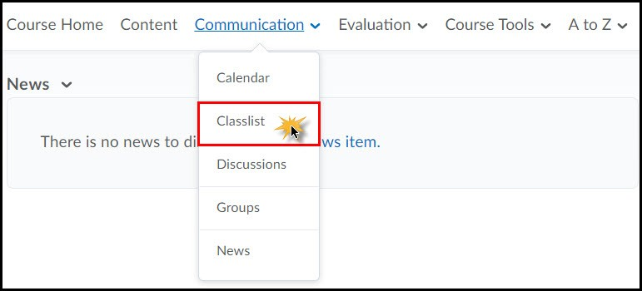
To access the Classlist in D2L, click on the Communication link group located in the top navigation bar and select Classlist from the drop-down menu.
The Classlist stores information about the faculty and students enrolled in your D2L course. You can use Classlist to see who is online, send emails, page classmates, view blogs, and make changes to your public profile information. Use the image and related reference material below to familiarize yourself with the layout of the Classlist page.

Navigating the Classlist
The Classlist screen is organized by user role. There are four different user role tabs at the top of the page. Use these user role tabs to toggle between the different types of users enrolled in a specific class.
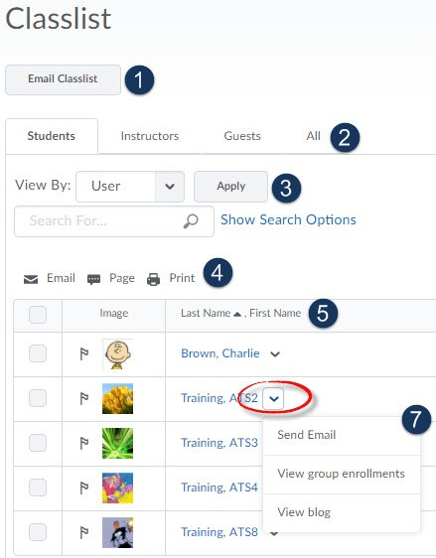

- Email Classlist – This button allows you to send an email to your entire classlist. Note that any replies you receive to this email will be routed to your Goldmail email account.

- Role Tabs – Use these tabs to sort the classlist by user role. By default, the classlist displays only students. Clicking the ALL tab will show you a list of both students and instructors.

- Search and Filter Options – Use the Search For textbox to search for a classmate or instructor. Note that the search box will only search the active role. For example, if you perform a search for your instructor while the Students tab is active, your search will yield no results. The View By option allows you to display only those students who are a member of a particular group or section. By default, all users are displayed.

- Actionable Hyperlinks – Use these hyperlinks to perform actions on a select group of students. For example, marking the checkbox to the left of a student’s profile picture and then clicking the Page hyperlink will allow you to send an instant message to the selected student.
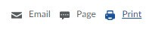
  - Select All - When marked, the select all checkbox will select all of the users in view on the classlist.
  - Email - The Send Email option will pop open a window that allows you to send an email to a particular student or instructor or group of students/instructors.
  - Page – The Page option will allow you to send an instant message to each user you have selected from the classlist.
  - Print – The Print option allows you to print a list of all users you have selected. By selecting all users, you can print a whole classlist.

- Headings – Use these interactive table headings to sort the classlist by last name, first name, username, or role. The small arrow displayed to the right of a heading signifies the current sort order.

- Active– A green dot to the right of a user’s name signifies that he or she is currently online and active in the learning environment.

- Context Menu – Use this context menu to explore more information and options for a particular student or instructor in your class. To access the context menu for each user, click the downward- facing arrow to the right of a user's name.

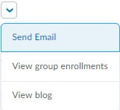
  - Send Email – The Send Email option will pop open a window that allows for you to send an email to a particular student or instructor.

  - View Group Enrollments - The View Enrollments option will allow you to view which groups a user is enrolled in.

(May not be available in all classes.

- View Blog - The View Blog option will allow you to view the selected user's blog. You can only view items the user has made public.

Email and the Classlist

Sending an Email through the Classlist

You may choose to email individual users through the classlist, all users who fall within a particular category or tab (i.e. all students), a select group of users, or you may email everyone in the classlist.

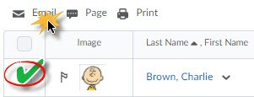
To Email One User:

Locate the user in the classlist

Mark the checkbox to the left of the user’s profile picture

Click the Email hyperlink

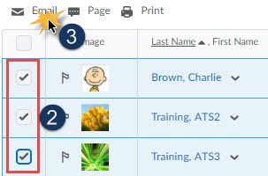
To Email Multiple Users:

- Locate the users in the classlist
- Mark the checkbox to the left of the users’ profile pictures
- Click the Email hyperlink

To Email the Entire Classlist:

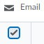
  - Click on the ALL tab to display all users in the classlist and ensure that all users are displayed. Note that sometimes D2L divides users across multiple pages. You may have to change the number of users-per-page.
  - Click the Select All checkbox
  - Click the Email hyperlink

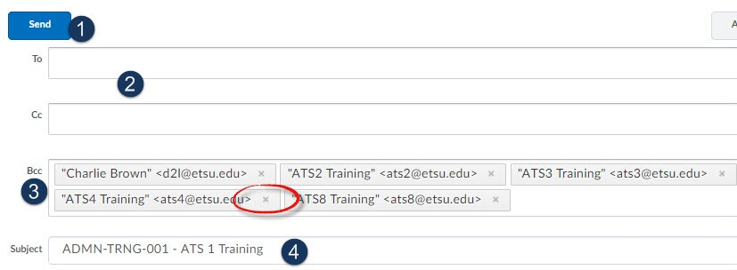
After clicking the email hyperlink a new window will open which allows you to compose a new message.
- Send - Once you have finished composing your email message, click the send button to send the email to your intended recipients.

- To/CC Fields – You may type in additional email addresses in the TO and CC fields. Note that you must type out the entire email address. You can include multiple addresses by separating each address with a semicolon.

- BCC Field – The email addresses of the users you selected from the classlist will automatically populate in this field. Click the small X, located on the far right-hand side of each address, to remove the email address.

- Subject Line – The system will automatically populate the course code and course name in the subject field. You may edit this field if you wish.

- Email Body – Compose your email in the body textbox. You may use any of the formatting options available to you.

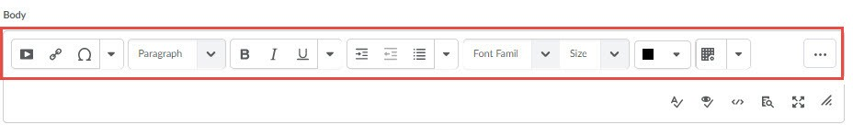

- Upload Attachments – If you would like to include an attachment with your email, use the Upload button to attach a file(s) to the email.

