**Unhealthy Block Scheduling**

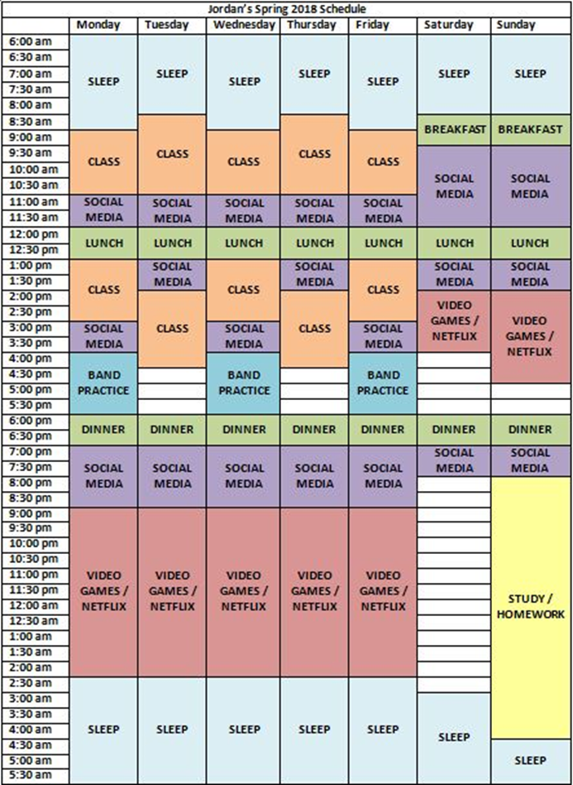

**Healthy Block Scheduling**

