AI Usage Guide
Please refer to this guide when symbols for assignments are provided. With the exception of instructor-sanctioned use of an AI-generated starting draft, you should not submit any AI-generated writing to represent your own (this is akin to plagiarizing). If, for some reason, you wish to include an AI-generated quote, please credit the AI used.
AI Usage Symbol | Symbol Explanation | Reasoning
 | Please avoid the use of generative AI for this assignment. | Sometimes we have to do the hard work of learning ourselves. If AI were used on this assignment, that would limit your brain’s needed “workout” to do the processing and practicing necessary for deeply learning this content – content which will be important to automatically know for future, more complex thinking and problem-solving.
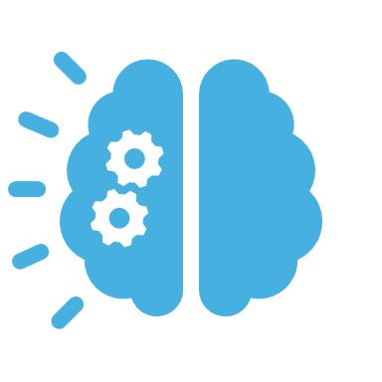 | For this assignment, you may use generative AI to help you brainstorm ideas or better understand a concept through a generative-AI “conversation.” All written work that may stem from this AI interaction should be your own creation. If you use an idea generated from AI, please credit it. | Getting started can sometimes be the thing that holds us up. If you need gen-AI to either think outside the box or understand a concept to learn better or proceed on this activity, then it is a tool worth using.
 | For this assignment, you may use (or are asked to use) generative AI to give you feedback on your own original work.  Please include in your submission: Your un-edited draft, your AI prompt*, and your edited draft with changes marked after receiving feedback. [* It is possible your instructor will give you a specific prompt to use to request feedback, in which case including the prompt is not necessary.] | This is an opportunity for you to learn how to use gen-AI for feedback on written work, helping you to see where improvements can be made. Making the actual changes yourself, however, helps you learn the detail skills needed for good written communication.
 | For this assignment, you may use (or are asked to use) generative AI to create an initial outline or draft, which you then significantly alter on your own.  Please include in your submission: The original (AI-generated) draft, and your updated draft with all of your own changes marked. | The goal of this activity is more sophisticated than the basic, initial writing that is involved. Presuming you know the basic skills of preparing a draft of this assignment, we will save time by building onto a basic product (from gen-AI) and use that time to apply higher-order thinking and learning to it.

